Technical Datasheet IO Modules with Modbus RTU Protocol with RS485 Interface

The I/O modules communicate via RS485. The port can drive distances up to max 700 meters without the use of any repeater (this feature however also depends on the signal strength of the Modbus Master Device).
The RS485 Digital Sensor module is sturdy, low power usage and easy to use.
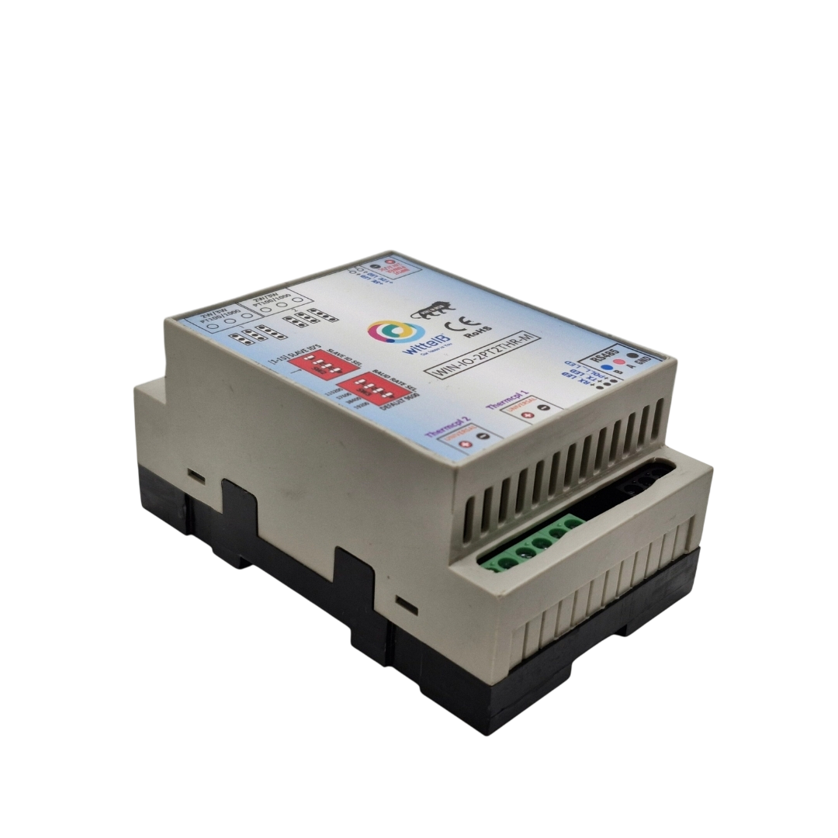
2 PT100/1000-2 Thermocouple Module:-

Our Multi-Channel Temperature Measurement System is a versatile and high-precision solution designed for diverse temperature sensing needs. The system integrates Modbus RS485 communication for robust and reliable data transmission. With dual channels for RTD (PT100/PT1000) measurement and dual channels for thermocouple measurement, this device is ideal for industrial, commercial, and scientific applications requiring precise temperature monitoring and remote data access.

Dual RTD Channels:-

- Features two channels for RTD measurements, capable of reading both PT100 and PT1000 sensors.
- Utilizes advanced analog-to-digital conversion technology for accurate and reliable temperature readings.

Dual Thermocouple Channels:-

- Includes two channels for thermocouple measurements, compatible with various thermocouple types (K, J, N, R, S, T, E, B).
- Ensures precise temperature monitoring across a wide range of applications.
- The I/O modules are housed in a DIN rail mountable casing with exposed connectors and LED indicators for easy status monitoring. The DIP switches for setting the Slave ID and Baud rate are conveniently located inside the enclosure.
- The modules feature resettable fuses to protect against reverse polarity connections on both the power and communication ports, ensuring safety and reliability.

Specifications
General:-
Connectors 2 Pin 5.08 mm pitch pluggable screw terminals.
Dimensions 70 mm L x 110 mm B x 50 mm H
Power Input Power – 24 V AC/DC
Typical – 12V DC @ 80mA
Operating Temperature 0 – 60° C (32 ~ 140°F)
Storage Temperature -20 - 70° C (-4 ~ 158°F)
Storage Humidity 5 ~ 95 % RH, non – Condensing

Certifications

AI Inputs:-
Channels 4
Input Signal 2–PT100/PT1000–(jumper selectable)-Two wire/Three wire
2–Thermocouple – (K, J, N, R, S, T, E, B).
Accuracy Total Accuracy over All Operating Conditions: 0.5NC
(0.05% of Full Scale) max.
Input Resolution 15-Bit ADC Resolution for PT’s And 19-Bit ADC
Resolution for Thermocouple.
Isolation Optically Isolated.

Additional Features:-
Communication port isolated
Input power reverse polarity safety
ESD Safety IEC 61000-4-2, ± 30KV contact, ± 30KV air
EFT IEC 61000-4-4, 50A (5/50ms)
750V isolation.
CRC Error check.
No configuration needed on the IO board

Configuration Settings:-
Communication Speed 9600 – 19200 Kbps (DIP SW Selectable)
Data Bits 8
Parity None
Stop bit 1
CRC Yes
Slave ID 1-15 (DIP SW Selectable)
Function Code 0x03 Read Holding Registers
AI Register Address 0,1,2,3

ID | Function  Description | Register  Description | Modbus Function Code | Protocol | Data  Type
0 | RTD1 | 40001 | 0X03 | RS485 | 16 Bit Unsigned int
1 | RTD2 | 40002 | 0X03 | RS485 | 16 Bit Unsigned int
2 | THR1 | 40003 | 0X03 | RS485 | 16 Bit Unsigned int
3 | THR2 | 40004 | 0X03 | RS485 | 16 Bit Unsigned int

Recommended Cable Electrical Characteristics:-
22 AWG Cable Shielded and twisted pair should be used
Tinned Copper Recommended
Nominal Conductor DCR 14.7 ohm / 1000 ft
Nominal Capacitance 11 pf / feet (conductor to conductor)
High Frequency Non-Insertion Loss 0.5db / 100ft

Note:-
For MODBUS communications, a shielded and twisted pair cable is used. One example of such cable is Belden 3105A.
BAUD RATE DESCRIPTION:-
LSB
MSB
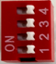
- For Baud rate Selection, DIP SW is used as per the diagram.
- Pulling up the switch will make Baud rate active.
- If no selection is made 9600 will be default Baud rate.
- When you change the Baud rate in the Module power ‘ON’ condition,
please press the reset button to get Change to affect.
Baud Rate | DIP SWITCH
 | 1 | 2 | 3 | 4
9600 | OFF | OFF | OFF | OFF
19200 | OFF | OFF | OFF | ON
38400 | OFF | OFF | ON | OFF
57600 | OFF | ON | OFF | OFF
115200 | ON | OFF | OFF | OFF

SLAVE ID DESCRIPTION:-
MSB
LSB


- For Slave ID Selection SW is used to Set The SLAVE ID .
- For Slave ID DIP Switch LSB is “1” follow through “4” is MSB.
- Slave ID Confirmed through below Device ID table .
- IF Eg. Slave ID 1 is Needed to be selected Switch number 1 should pulled up other three should be selected down side. So”1 0 0 0” will be selected as Slave ID 1.

Slave ID | DIP SWITCH |  |  |  | OUTPUT (Binary) | OUTPUT (Decimal)
 | 1 | 2 | 3 | 4
0 | OFF(0) | OFF(0) | OFF(0) | OFF(0) | 0 0 0 1 | 1
1 | ON(1) | OFF(0) | OFF(0) | OFF(0) | 0 0 0 1 | 1
2 | OFF(0) | ON(1) | OFF(0) | OFF(0) | 0 0 1 0 | 2
3 | ON(1) | ON(1) | OFF(0) | OFF(0) | 0 0 1 1 | 3
4 | OFF(0) | OFF(0) | ON(1) | OFF(0) | 0 1 0 0 | 4
5 | ON(1) | OFF(0) | ON(1) | OFF(0) | 0 1 0 1 | 5
6 | OFF(0) | ON(1) | ON(1) | OFF(0) | 0 1 1 0 | 6
7 | ON(1) | ON(1) | ON(1) | OFF(0) | 0 1 1 1 | 7
8 | OFF(0) | OFF(0) | OFF(0) | ON(1) | 1 0 0 0 | 8
9 | ON(1) | OFF(0) | OFF(0) | ON(1) | 1 0 0 1 | 9
10 | OFF(0) | ON(1) | OFF(0) | ON(1) | 1 0 1 0 | 10
11 | ON(1) | ON(1) | OFF(0) | ON(1) | 1 0 1 1 | 11
12 | OFF(0) | OFF(0) | ON(1) | ON(1) | 1 1 0 0 | 12
13 | ON(1) | OFF(0) | ON(1) | ON(1) | 1 1 0 1 | 13
14 | OFF(0) | ON(1) | ON(1) | ON(1) | 1 1 1 0 | 14
15 | ON(1) | ON(1) | ON(1) | ON(1) | 1 1 1 1 | 15

NOTE:-By default, the Jumper setting on the board is PT100.

THR2 THR1 AI1
RTD1 RTD2 AI4
Input12-24 VAC/DC
Modbus RS 485
Slave ID
Baud Rate
Jumper
PT100/PT1000
Jumper
2/3 Wire

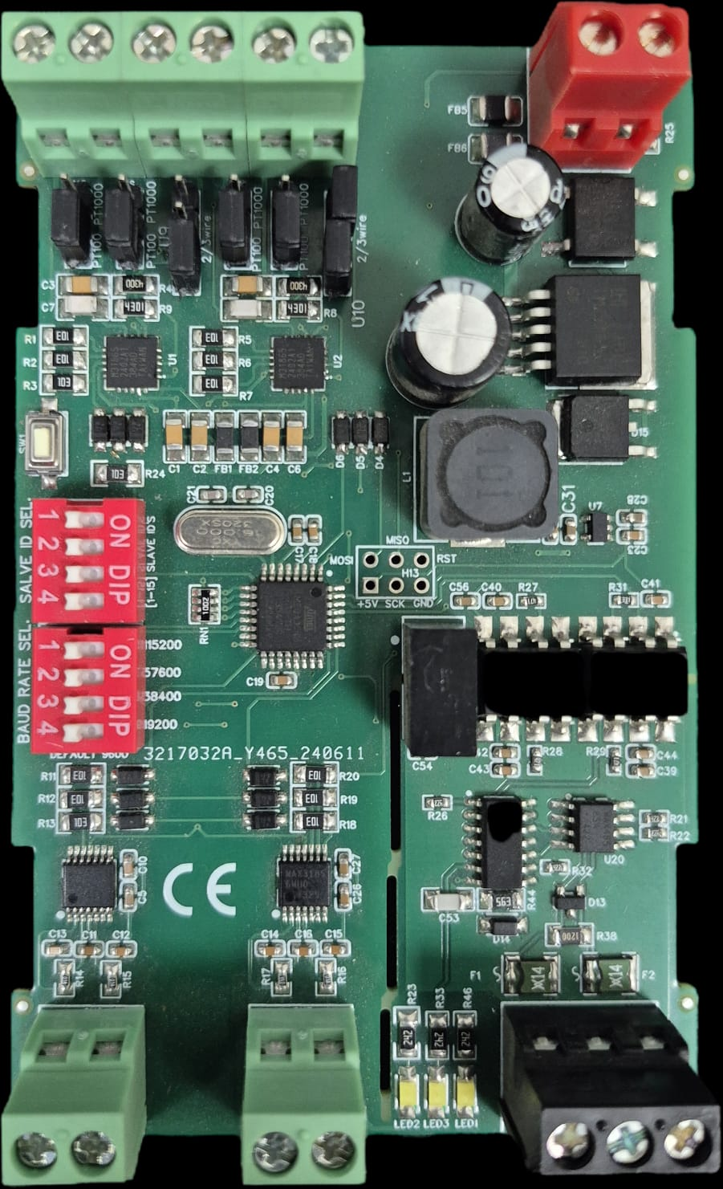

Contact us: -
Augmatic Technologies Pvt. Ltd.,
Plot no 6, Shah Industrial Estate II,
Kotambi, Vadodara – 391510.
Email – Sales@wittelb.com
Support: support@wittelb.raiseaticket.com / +91 94038 92805

